STOCK MARKET ANALYSIS

**A ANALYSIS OF META PLATFORMS, INC. CLASS A COMMON STOCK**

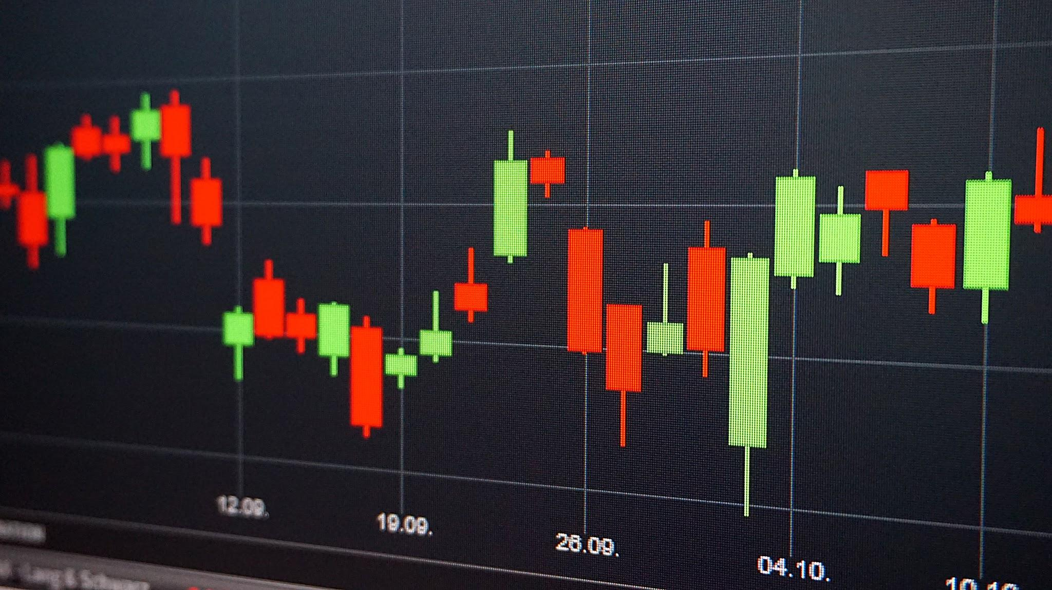

## NAME: J ASHOK CHANDRA

DR LANKAPALLI BULLAYYA COLLEGE

BBA FINAL YEAR

REGD NO: 121128807006

03/04/2024

**TABLE OF CONTENTS**

# **Introduction**

## Overview of the company.

## Overview of the company’s stock.

# **Stock Performance Analysis**

## Key Performance Indicators

# **Comparison with Relative Stock index**

# **Analysis of External Factors influencing Stocks**

# **Conclusion & Bibliography**

**INTRODUCTION**

# **Overview of the company: (Meta Platforms, Inc.)**

Meta Platforms, Inc., doing business as Meta, and formerly named Facebook, Inc., and TheFacebook, Inc., is an American multinational technology conglomerate based in Menlo Park, California. The company owns and operates Facebook, Instagram, Threads, and WhatsApp, among other products and services. Meta ranks among the largest American information technology companies, alongside other Big Five corporations Alphabet, Amazon, Apple, and Microsoft. The company was ranked #31 on the Forbes Global 2000 ranking in 2023. Meta has also acquired Oculus, Mapillary, CTRL-Labs, and a 9.99% stake in Jio Platforms; the company additionally endeavored into non-VR hardware, such as the discontinued Meta Portal smart displays line and presently partners with Luxottica through the Ray-Ban Stories series of smart glasses. Despite endeavors into hardware, the company relies on advertising for a vast majority of its revenue, amounting to 97.8 percent in 2023. Parent company Facebook, Inc. rebranded as Meta Platforms, Inc. on October 28, 2021, to "reflect its focus on building the metaverse", an integrated environment linking the company's products and services.

# **Overview of the company’s stock:**

**Meta Platforms, Inc. CLASS A Common Stock (**META**)**

| **Exchange** | NASDAQ-GS | **Sector** | Technology |
| --- | --- | --- | --- |
| **1 Year Target** | $525.00 | **Industry** | Computer Software:  Programming, Data Processing |
| **Today’s High/Low** | $497.53/$484.65 | **Share Volume** | 11,081,026 |
| **Average Volume** | 18,009,751 | **Previous Close** | $491.35 |
| **52 Week High/Low** | $523.57/$207.13 | **Market Cap** | 1,267,997,617,571 |
| **P/E Ratio** | 33.38 | **Forward P/E 1 year** | 24.64 |
| **EPS** | $14.90 | **Annualized Dividend** | $2.00 |
| **Ex Dividend Date** | February 21, 2024 | **Dividend Pay Date** | March 26, 2024 |
| **Current Yield** | 0.41% |  |  |

STOCK PERFORMANCE ANALYSIS

This section includes the KPIs used to analyze the performance of **Meta Platforms, Inc. Class A Common Stock.** Which are as follows:

## **PERCENTAGE CHANGE IN STOCK PRICE:**

To determine the percentage change in stock price of the meta platforms, inc. class A common stock the closing prices of the stock on the initial day of the year and the final day for the fiscal year 2023-24 has been taken.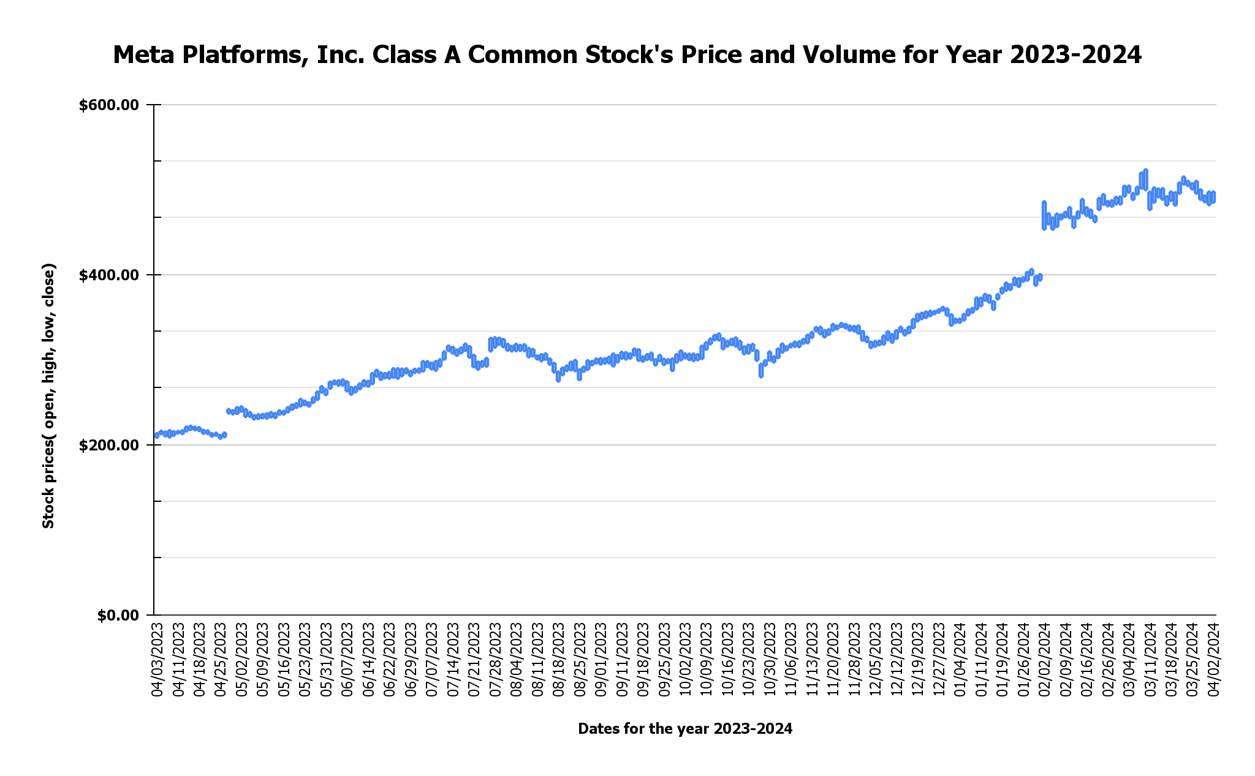

**GOOGLE SHEET SOURCE ( J ASHOK CHANDRA DRIVE) :** [Ashok chandra GRAPHS](https://docs.google.com/spreadsheets/d/1q8cKN4SfQ-xrtVdeuqW9MNPHVLLLscTNl5__2XrH5YE/edit?usp=sharing)

* The above **Candlestick** shows the Meta class A common stock price movements for the year 2023-2024.
* The stock’s closing price at the beginning of the year was **$213.07** per share on **3rd April 2023.**
* The stock’s closing price at the end of the year i.e current market price is **$497.37** per share on **2nd April 2024.**
* **Therefore,** the Percentage% change of the **Meta class A common stock price** from the **beginning of the year** to the **ending of the year** is **133.43%.**

## **STOCK PRICE VOLATILITY:**

To calculate and determine price volatility of **Meta’s Class A common stock**, **standard deviation** and **bollinger bands** have been used. The high standard deviation value shows higher stock price volatility i.e high frequency of price movements between the HIGH and LOW bollinger price bands.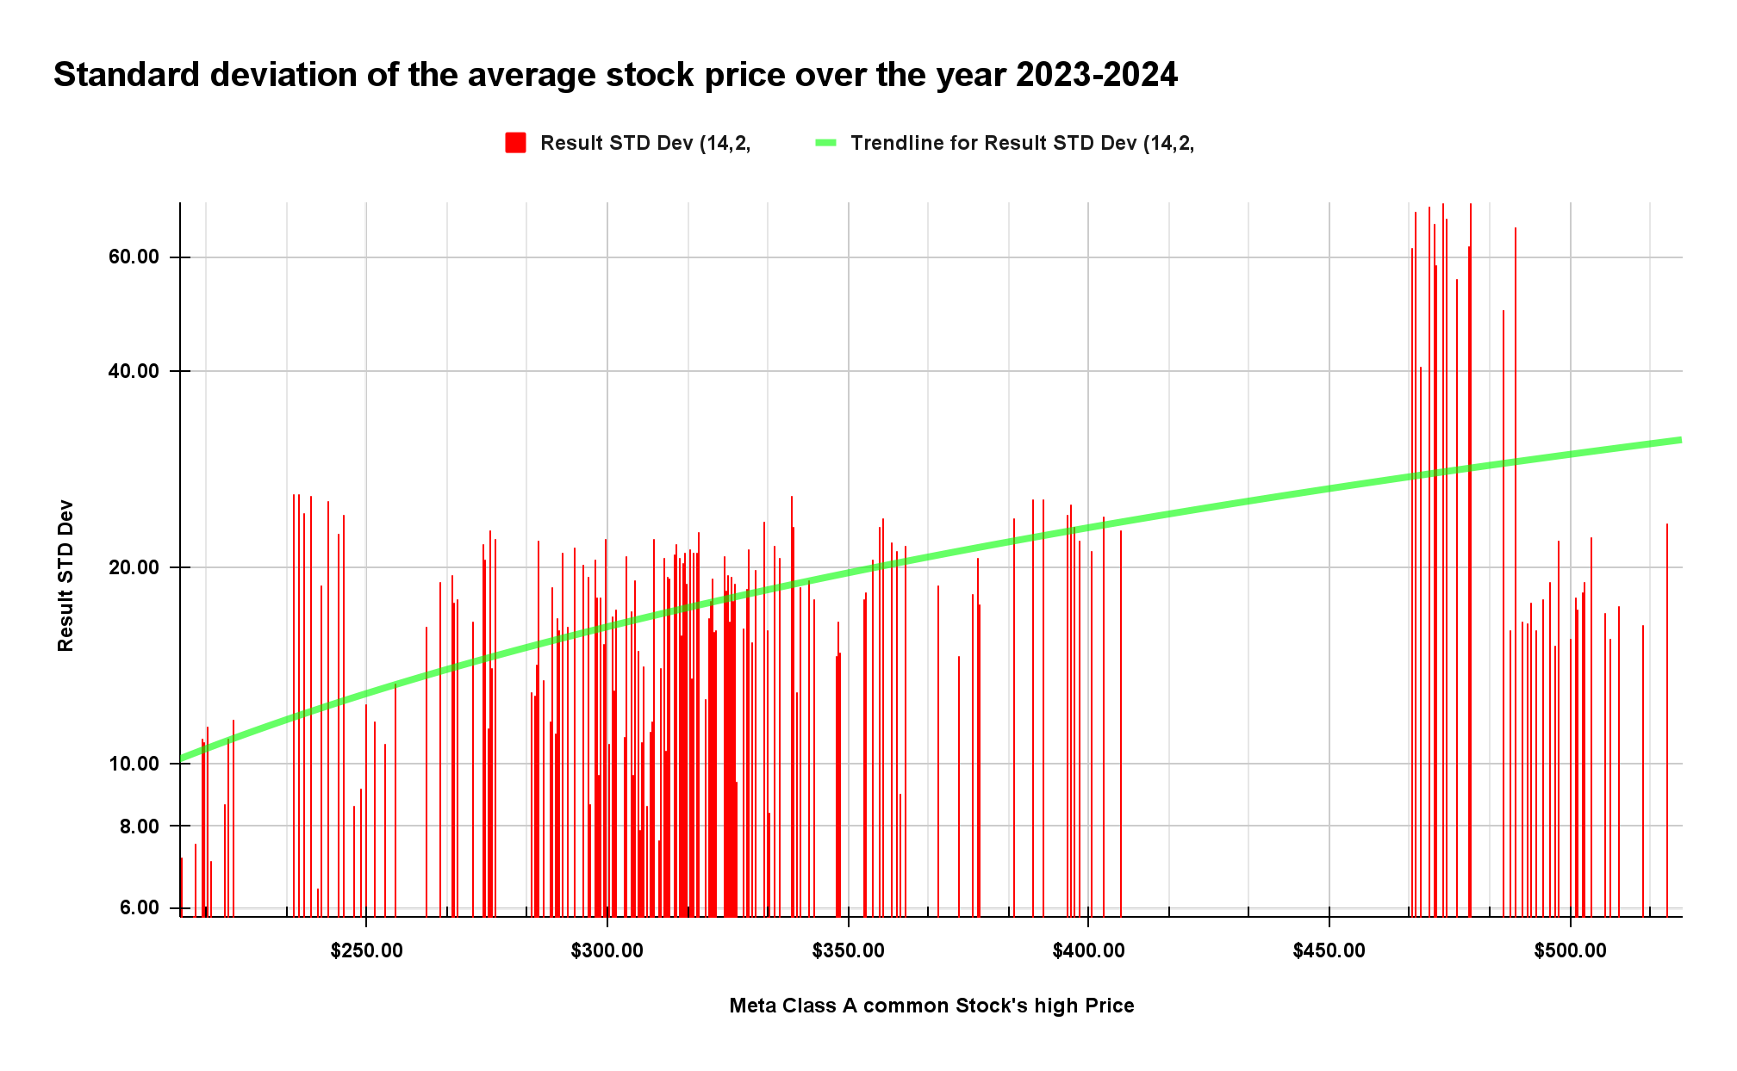

* **The above chart shows standard deviation calculated on the stock’s prices over the year 2023-2024. :** [Ashok chandra GRAPHS](https://docs.google.com/spreadsheets/d/1q8cKN4SfQ-xrtVdeuqW9MNPHVLLLscTNl5__2XrH5YE/edit#gid=2100055870)
* Meta’s stock price movement was more agile between the price range of **$450-$490 per share.**
* **The below chart shows the Price movement of Meta’s Class A common Stock for the year 2023-2024:** [Ashok chandra GRAPHS](https://docs.google.com/spreadsheets/d/1q8cKN4SfQ-xrtVdeuqW9MNPHVLLLscTNl5__2XrH5YE/edit#gid=2023222140)
* **The chart displays the opening, high, low, closing price of the stock along with the TOP, BOTTOM and MEDIAN BOLLINGER PRICE BANDS.**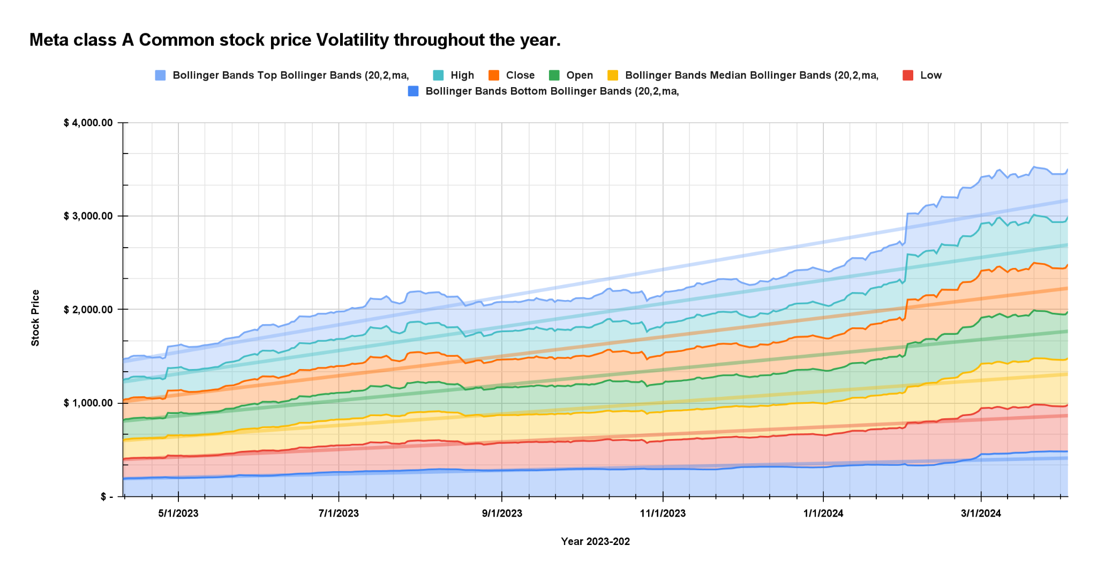

## **AVERAGE TRADING VOLUME:**

The average trading volume for Meta stocks over the year has been illustrated through the following **Area chart.**

* The chart shows the daily average trading volume for the year’s active days.
* Total trading volume of **Meta Class A common stock** in the year 2023-2024 is **5,159,908,035.00.**
* **The average trading volume (ADTV) of the META STOCK IS 20,557,402.53.**

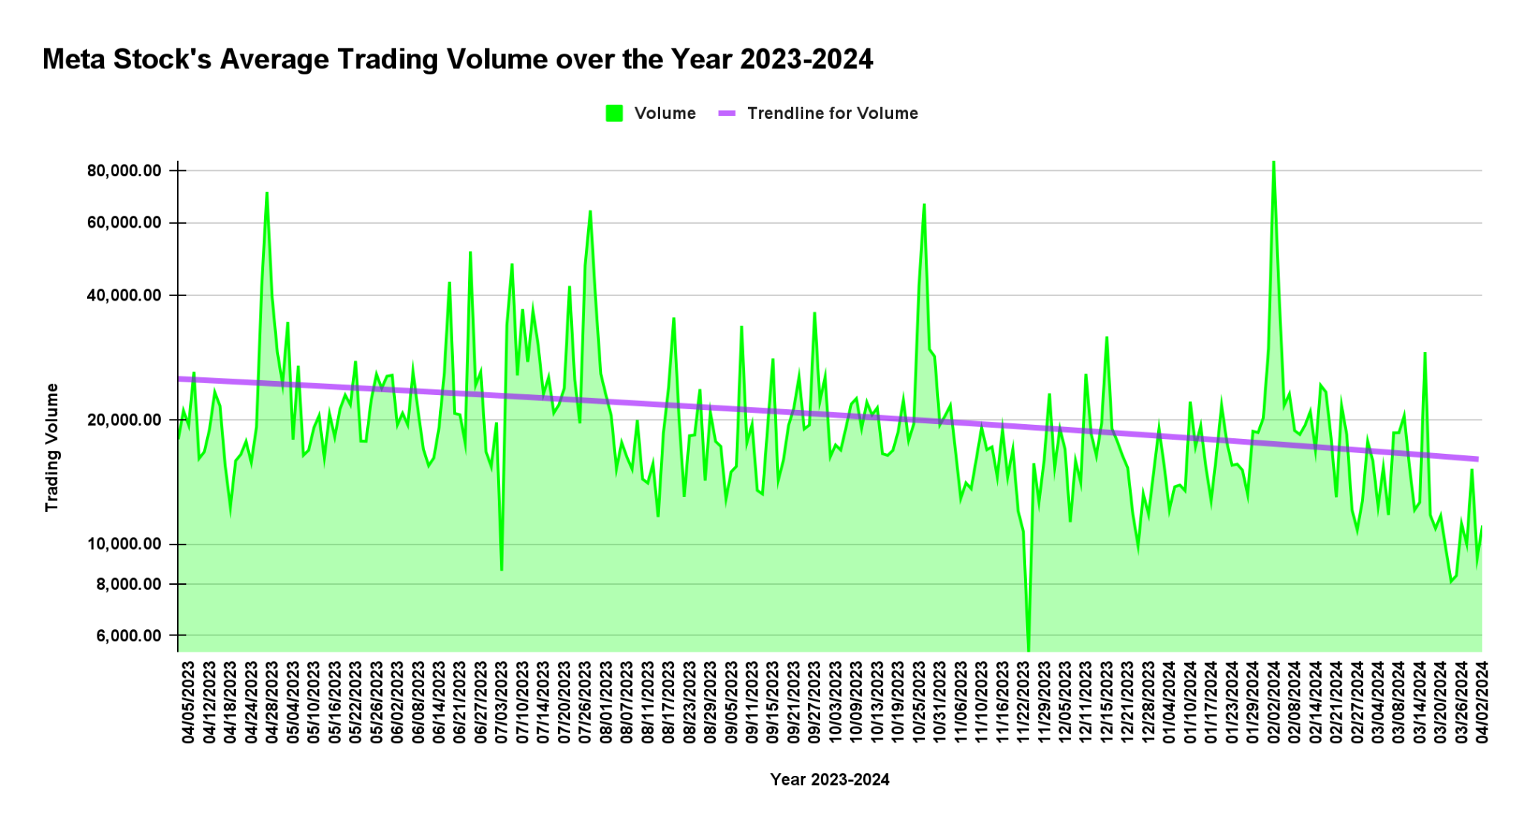

**COMPARISON WITH RELATIVE STOCK INDEX**

## **STOCK PRICE PERFORMANCE OVER THE YEAR:**

The **Meta Class A common stock** has been compared with **SPX ( S&P 500)** and .**NCOMP ( Nasdaq Composite)** for the year 2023-2024. The following Line chart has been used to show the stock performance against the two indices. :

[Ashok chandra GRAPHS](https://docs.google.com/spreadsheets/d/1q8cKN4SfQ-xrtVdeuqW9MNPHVLLLscTNl5__2XrH5YE/edit#gid=2036809620)

* Meta Class A Common Stock Experienced a **133.43%** Growth from 2023 to 2024 April 2nd.
* SPX ( S&P 500) index Experienced a **25.27%** Growth from 2023 to 2024 April 2nd.
* .NCOMP ( Nasdaq Composite) index Experienced a **33.39%** Growth from 2023 to 2024 April 2nd.

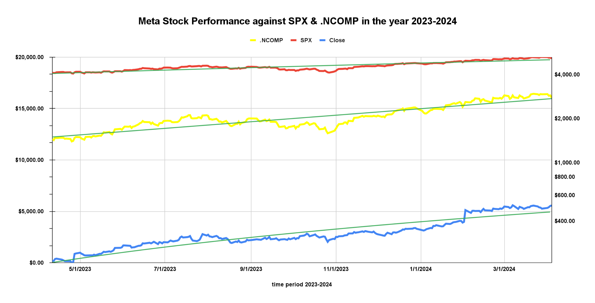

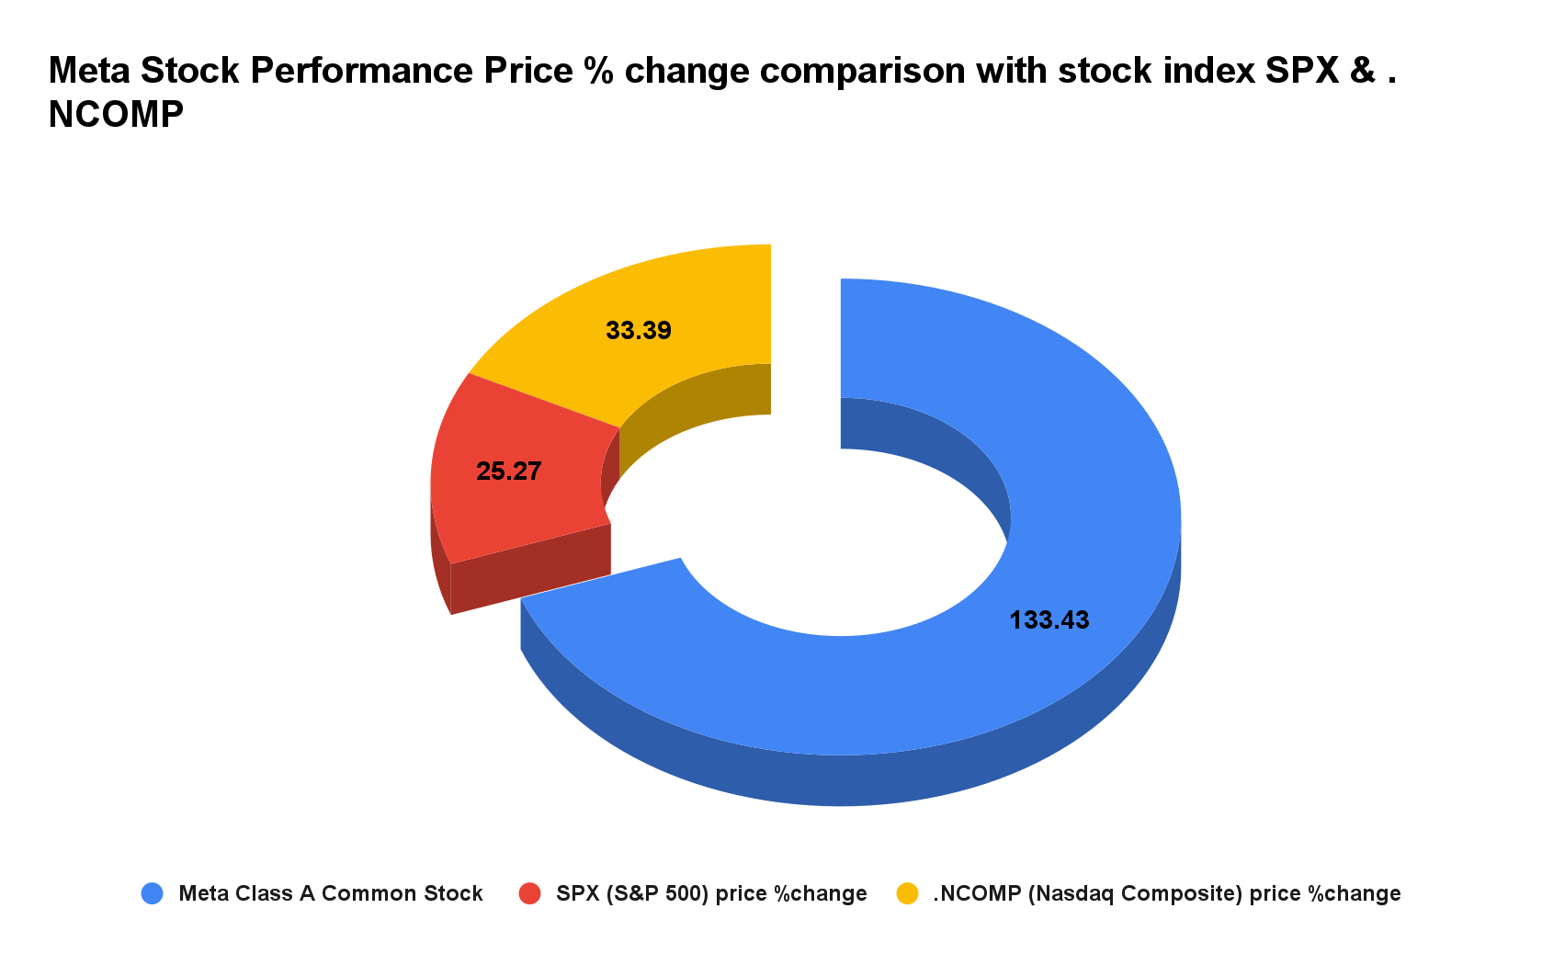

**ANALYSIS OF EXTERNAL FACTORS INFLUENCING THE META STOCKS**

## This section covers the significant events which affected the shares/ stocks of Meta Platforms, Inc. which are as follows:

### **#1-** **April 27 2023 -** **Meta CEO Mark Zuckerberg’s** **wealth soars by $10 billion after a strong quarter, 2 rounds of layoffs. (13.93% increase)**

The surprising earnings report caused a 14 per cent surge in Meta's shares, raising Zuckerberg's fortune to $87.3 billion, which propelled him up to the 12th place in the Bloomberg Billionaires Index.A report by Bloomberg claims that this spike in wealth marks the highest point his net worth has reached in over a year, reversing the decline he experienced in 2022, when his net worth fell by $71 billion.

During the earnings call, Zuckerberg encouraged continued investment in the areas of artificial intelligence and virtual reality. The Menlo Park-based company has focused on reducing costs through lower spending and layoffs, with the CEO referring to it as "the year of efficiency."

The company's pivot towards the metaverse has previously raised concerns over its growth prospects. However, with the latest earnings report and cost-cutting measures, the outlook appears to be more positive, driving up the company's stock price and subsequently, the CEO's net worth.

### **#2- July 27 2023 - Facebook-Parent Meta Sees 11% Surge In Revenue, Outpaces Google’s Ad Growth. ( 4.40% increase)**

During the second quarter, Meta's revenue surged by 11 per cent, reaching $32 billion. This figure exceeded analysts' estimates, which were around $31.12 billion. The company also saw a 12 per cent rise in ad revenue during the same period, outpacing Google's ad revenue growth, which stood at 3 percent. Furthermore, Meta's adjusted earnings per share of $2.98 surpassed Wall Street's expectations of $2.91.Meta has been experiencing a resurgence after facing challenges in 2022. The company's shares have doubled in value this year, driven by the excitement surrounding emerging AI technology and a significant reduction in its workforce.

In conclusion, Meta's strong advertising revenue performance, along with its continued investments in AI and metaverse technologies, is positioning the company for growth and innovation in the evolving tech landscape.

### **#3- October 26 2023 - Meta Q3 Results: Facebook Parent beats revenue, profit estimates, shares fall on warning over macro uncertainty. ( 3.73% decrease)**

The social media giant reported its best operating margins in two years and also trimmed expenses for the year.

Meta also warned again of regulatory pressures ahead, specifically a plan by the U.S. privacy regulator to toughen a 2019 order to include a ban on making money from minors' data.

“**We are very subject to volatility in the macro landscape,"** Li said on a call with investors. **“The revenue outlook is uncertain"** for 2024.

The comments put a damper on an otherwise upbeat earnings report. Meta shares initially climbed more than 5%, but declined over 3% in extended trading after executives expressed concerns about the macro environment. Meta shares have risen nearly 150% so far this year.

### **#4- February 02 2024 - Mark Zuckerberg has made a comeback with his wealth surging $27 billion as Meta shows immense growth after quarterly results. ( 20.32 increase)**

After releasing the company's quarterly results, Meta shares were up by 20 percent. With a significant surge in his wealth, Mark Zuckerberg's net worth crossed $169 billion on Friday, surpassing Bill Gates to move into the fourth spot on the Bloomberg Billionaires Index.

It’s a big comeback for Zuckerberg, whose wealth dropped below $35 billion in late 2022 as tech stocks collapsed in the face of inflation and interest rate hikes, only to soar in 2023.

Meta announced a quarterly cash dividend of 50 cents a share for Class A and B common stock beginning in March.

Meta has been employing major cost cutting measures, which has been credited as the reason behind the spike in share price. After Meta fired about 21,000 people and narrowed its priorities, the stock almost tripled in 2023.

The new dividend and an additional $50 billion in share buybacks may win more patience from investors with Zuckerberg’s long-term bets on artificial intelligence and the metaverse.

**CONCLUSION**

### Wells' analysts cited internal research into Meta's advertising performance that points to strong growth in the near term. The analysts expect the company to report strong results for the first quarter and issue solid guidance for Q2.

### In the fourth quarter, Meta's revenue grew 25% year over year, driven by a 21% increase in ad impressions and a 2% increase in price per ad across its family of apps.

### A key theme for the social media leader this year is investing in artificial intelligence (AI) tools to improve its ad systems and products. In Q4, Meta rolled out tools to build ads with text and images using generative AI, and it planned to make these tools more broadly available toward the end of the first quarter.

### Meta is loaded with cash to invest for growth. Free cash flow more than doubled in 2023 to $43 billion. Growing profitability and opportunities to drive strong advertising growth from AI explain the stock's run over the last year, and why it may continue to hit new highs.

### Despite the stock's climb, it still trades at a reasonable valuation, with a forward price-to-earnings ratio of 25. Assuming Meta continues to report strong earnings results, the stock has what it takes to hit the analyst's price target within the next year or Upcoming years.

## **References & Bibliography:**

* <https://www.google.com/finance/quote/META:NASDAQ>
* <https://www.nasdaq.com/market-activity/stocks/meta>
* <https://www.hindustantimes.com/business/mark-zuckerberg-becomes-27-billion-richer-as-meta-stock-rallies-net-worth-surpasses-bill-gates-101706943559781.html>
* <https://www.livemint.com/companies/company-results/meta-q3-results-facebook-parent-beats-revenue-profit-estimates-shares-fall-on-warning-over-macro-uncertainty-11698288052503.html>
* <https://news.abplive.com/business/meta-q2-quarterly-earnings-facebook-mark-zuckerberg-ad-revenue-llama-threads-instagram-1618734>
* <https://www.businesstoday.in/technology/news/story/meta-ceo-mark-zuckerbergs-wealth-soars-by-10-bn-after-strong-quarter-2-rounds-of-layoffs-379297-2023-04-28>

### 